EXPERIMENT NO - 1
AIM: Explore Linux commands.
TOOLS/SOFTWARES REQUIRED: Linux OS
THEORY:
In this experiment we explore many different Linux commands that can be used in the terminal. Some of these commands include:
- pwd: It tells us where we are in the Linux directory system.
- ls: It lists all the files and directories in the present working directory.
- mkdir: Allows us to create a new directory with a name of our choice.
- ps: This command displays information about current running processes.
- chmod: Let’s us change the mode for files, like adding or removing execute permissions to a file.
- uname: Provides us key details about our Linux system.

OUTPUT:
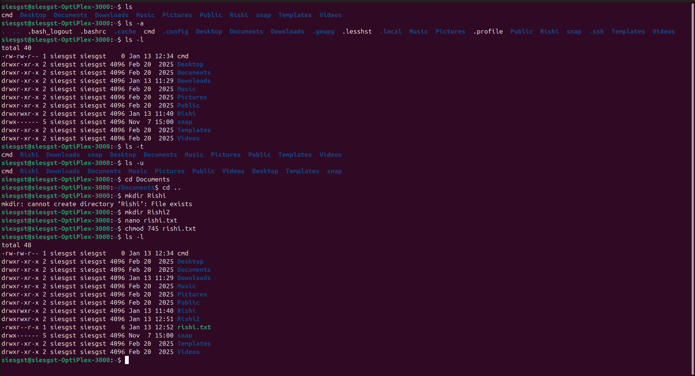
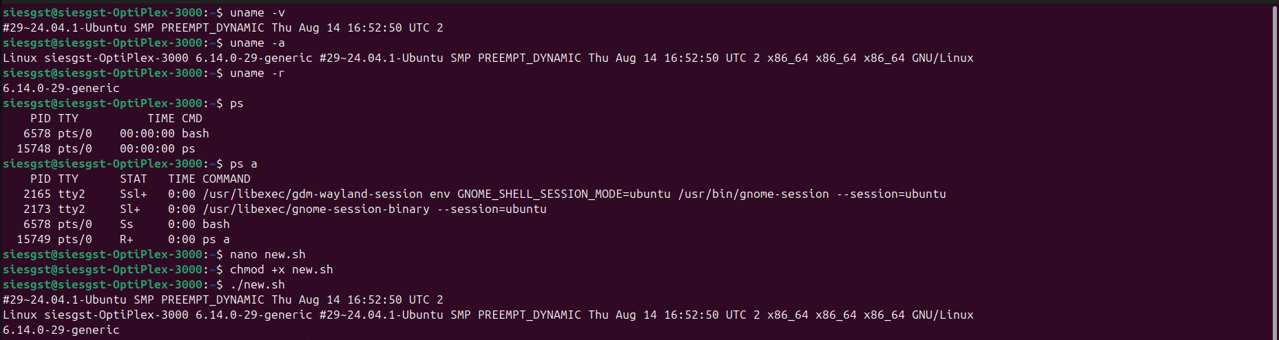
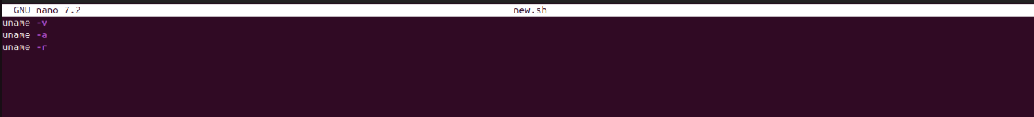
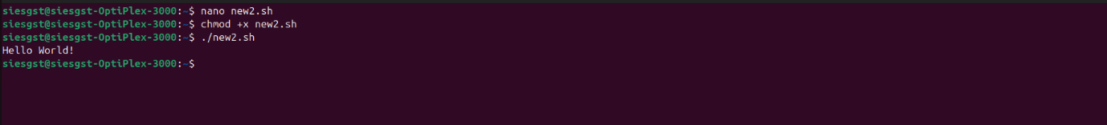
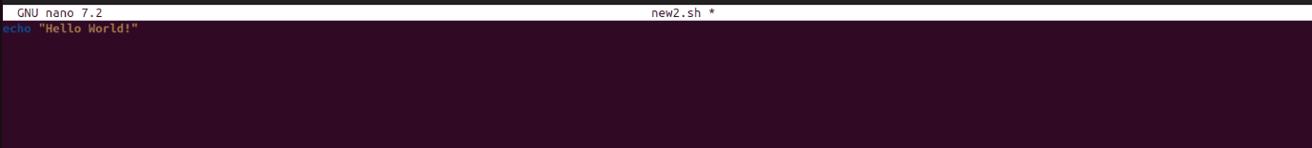
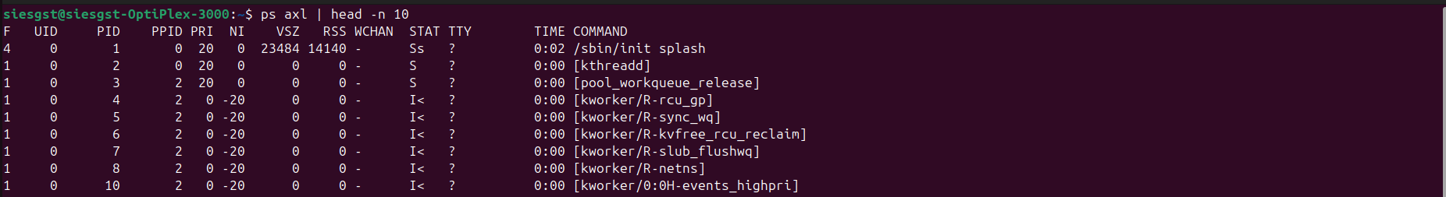
CONCLUSION: Hence, we have looked at different Linux commands on the Ubuntu Linux OS and learned why and how they are used.

